

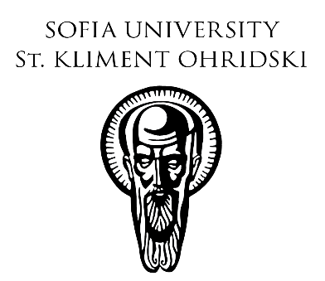

|  |  |  |  |  |  |
| --- | --- | --- | --- | --- | --- |
|  | |  |  |  | | --- | --- | --- | |  | SCIENTIFIC CONFERENCE  **THE EAST – NEAR AND FAR:**  **TEXTS, SOCIETIES AND CULTURES**  Department of Arabic and Semitic Studies  in collaboration with  Institute for Historical Studies – Bulgarian Academy of Sciences  **28 – 30 November 2024, Sofia**  Sofia University “St. Kliment Ohridski” – Rectorate, 15 Tsar Osvoboditel Blvd.  Bulgarian Academy of Sciences, 1, 15th Noemvri Str.  **On the occasion of the 50th anniversary of the Arabic Studies Program at**  **Sofia University and Bulgaria** |  | |  |

**APPLICATION FORM**

**Name and Surname:** …………………………………………………………………………………

**Academic position and degree:** ……………………………………………………………………..

**Affiliation:** ……………………………………………………………………………………………

**Paper title:** ……………………………………………………………………………………………

…………………………………………………………………………………………………………

**Abstract (up to 150 words):** …………………………………………………………………………

…………………………………………………………………………………………………………

…………………………………………………………………………………………………………

…………………………………………………………………………………………………………

…………………………………………………………………………………………………………

**Please email your application form by September 15, 2024** to Asst. Prof. Dr. Stoyan Doklev ([doklev@uni-sofia.bg](mailto:doklev@uni-sofia.bg)) and Assoc. Prof. Dr. Nadya Filipova ([nadyafd@abv.bg](mailto:nadyafd@abv.bg)).